Erin Sherman

Personal Project

CIS 440 Capstone Project Course

Personal Project Documentation

This is my personal website home page as it was before I started my project. The links were dead and did not go anywhere. There was a landing page already and a shell of what I wanted to do.   
  
For my personal project I’m going to finish my website – making it up to date and more appealing. Currently my website does not have any way to capture information entered in a contact form. I’d like to add some projects and testimonials as well to my site.

For this project I will need to utilize PHP that I haven’t used before as well as adding CSS3 and HTML5 attributes to the pieces of my site that I built many years ago. On the projects page I’d like to utilize some type of hover and zoom feature. See below image for starting screen shot.

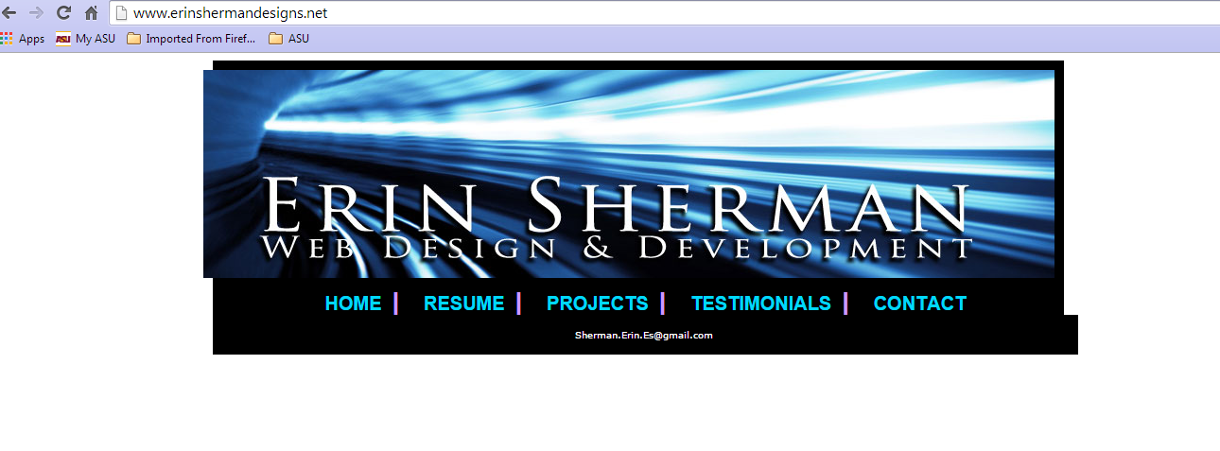

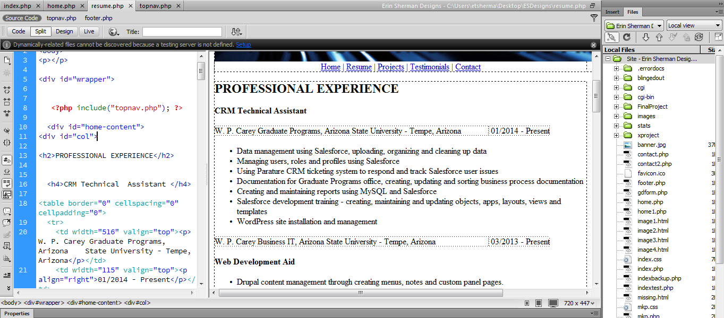

I use dreamweaver as an editor for my pages. From dreamweaver I have set up my personal FTP information to my Go Daddy hosting environment. Here in the screen shot above you can see the Resume page. Because I am using PHP to include pages the CSS does not apply to pages in the editor. While editing the CSS of my site I use Mozilla Firefox with a Web Developer Add on that I found. It is an extremely useful testing tool for CSS. (See screen shot below)

* Enter screen shot of CSS edits here –

On the project page I wanted to display images of a few different websites I built. In the screenshot below you can see on the right hand side the expanded file structure for all my images as well as the project page code. I found a good image viewer that was created with javascript to add to my site.

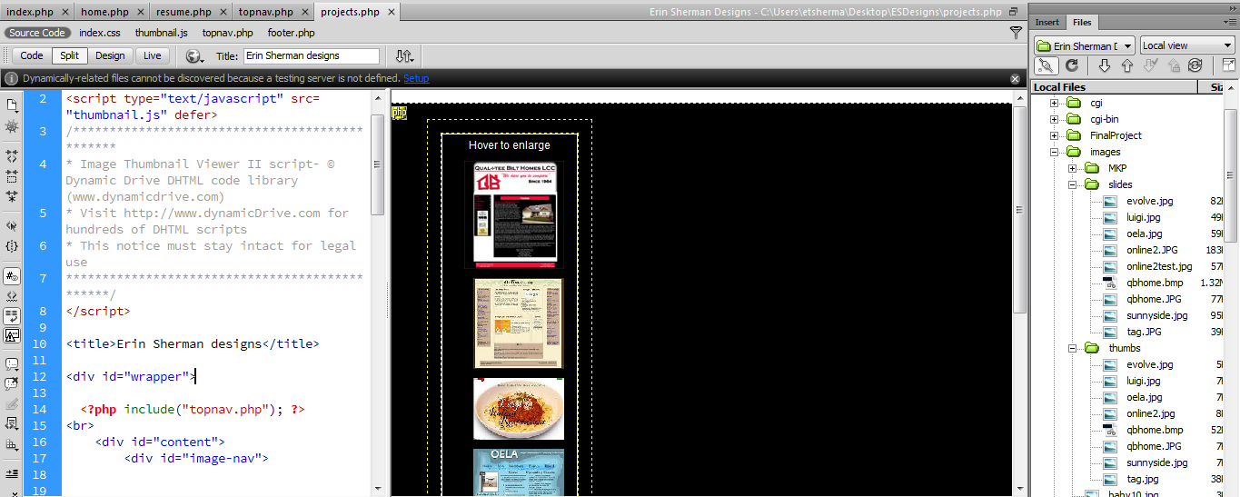

Contact Page: For the contact page I am going to set up a small database on my Godaddy hosting account to capture information from potential clients via a form on my site.

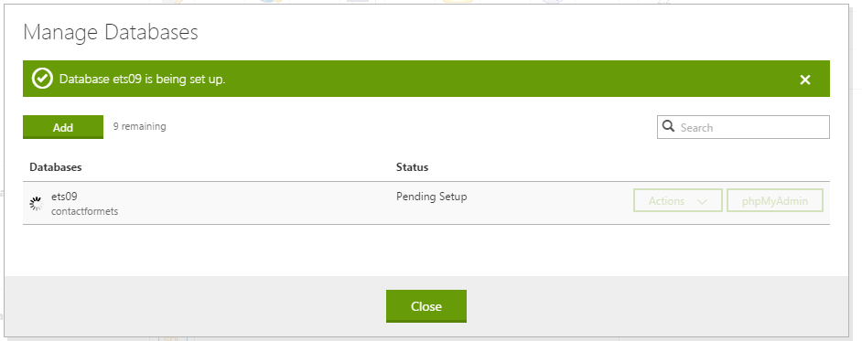

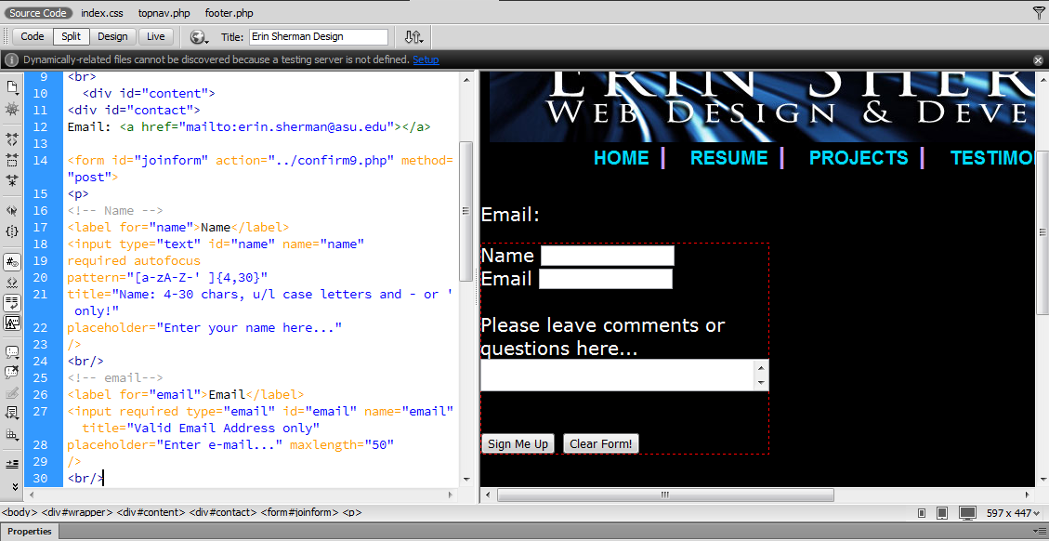

Database creation and submission was something that I had to learn for this project. I was able to figure out how to connect to my go daddy hosting server and create a database for the information. The screen shot below is showin the table in PHPmyadmin showing that the data is populating from the site contact form.

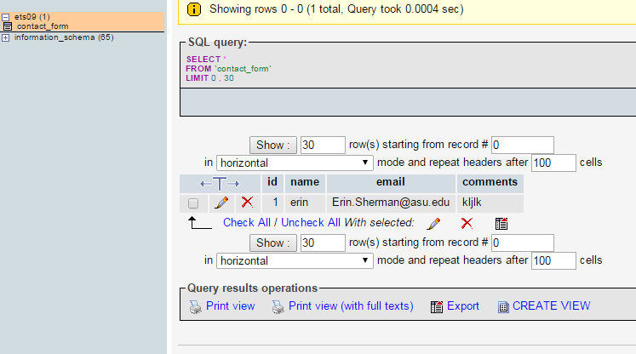

New CSS added to the Contact Form page – Previously had no CSS at all and was difficult to read the white on white text. See screen shot below for updated CSS on the contact form page.

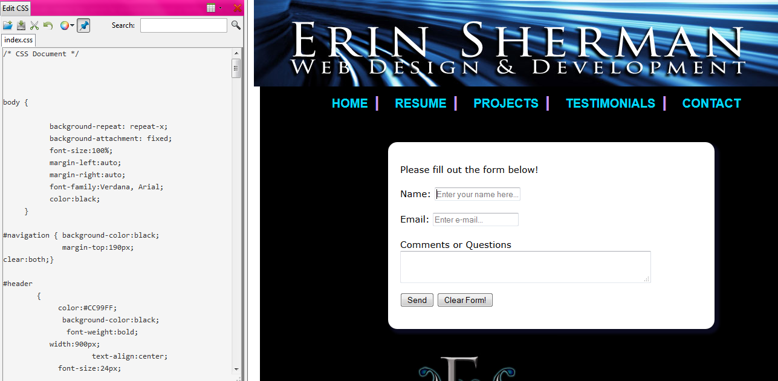

I added CSS to the Resume page to make the formatting of my text look appealing to read.

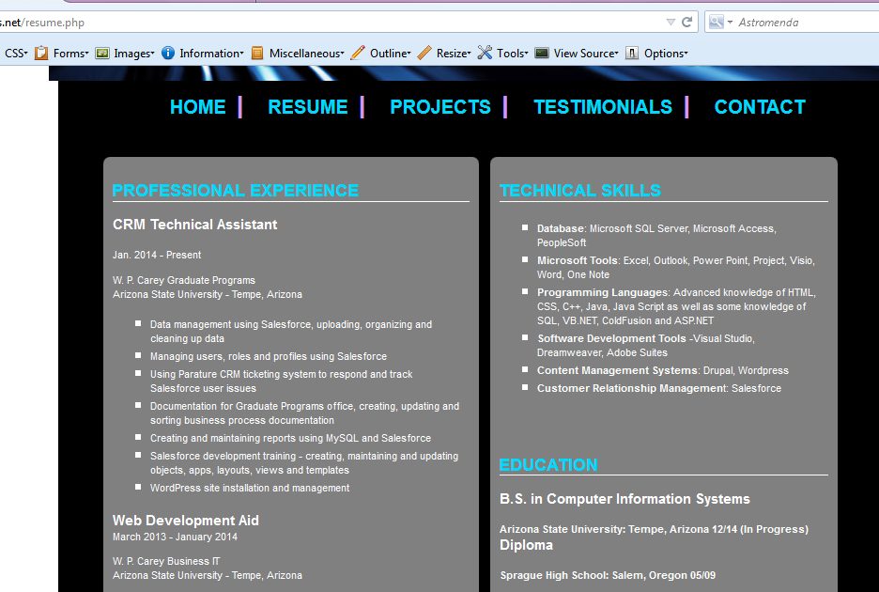

Please view my website : <http://erinshermandesigns.net/> Final Home page screenshot: 